Katherine Alexandra Tumbaco Sellan   202104485

Link: [GitHub - mbravop/CodingStandardsPY: Repository for Coding Standards Workshop, section A](https://github.com/mbravop/CodingStandardsPY)

## Scoring Guidelines

|  |  |
| --- | --- |
| **Score** | **Description** |
| 5 | Excellent: Meets all the criteria with no issues. |
| 4 | Good: Meets most criteria with minor issues. |
| 3 | Satisfactory: Meets some criteria but has noticeable issues. |
| 2 | Needs Improvement: Meets few criteria with significant issues. |
| 1 | Poor: Hardly meets any criteria. |
| 0 | Not Addressed: Does not meet the criteria at all. |

**Code Inspection Rubric**

|  |  |  |  |
| --- | --- | --- | --- |
| **Category** | **Criteria** | **Score – Y/N** | **Comments** |
| **Code Formatting** | Is the code consistently  formatted (indentation, spacing)? | 5 | This code implement correctly formatting |
| **Are line lengths reasonable and**  **within guidelines?** |  | 4 | In def sum exceeds 10 lines in code |
| **Are there unnecessary blank**  **lines or spaces?** |  | 4 | This code does have unnecessary white space lines. But it needs space |
| **Naming Conventions** | Are variable and function names descriptive and  meaningful? | 5 | The names are meaningful |
| **Are naming conventions consistent (camelCase,**  **PascalCase, etc.)?** |  | 5 | They use PascalCase. |
| **Comments and Documentation** | Are comments used where  necessary and helpful? | 5 | Does not use comment |
| **Is the code sufficiently documented to understand**  **functionality?** |  | Yes |  |
| **Are comments clear and concise?** |  | No | There are no comments |
| **Code Structure** | Is the code modular and divided into logical  functions/methods? | 5 |  |
| **Are there any long methods/functions that should**  **be broken down?** |  | Yes | In this code there is a long method sum |
| **Is there any duplicated code that**  **should be refactored?** |  | No | There is no duplicate code |
| **Logic and Functionality** | Does the code function as  intended? | No |  |
| **Are all the requirements**  **fulfilled?** |  | No |  |
| **Are there any obvious logic**  **errors?** |  | Yes | add space |
| **Are loop cases handled properly?** |  | No | Implement while |
| **Error Handling** | Are errors and exceptions properly caught and  handled? | No |  |
| **Is there any potential for**  **unhandled exceptions?** |  | No | Does not meet exceptions, implement in the future to avoid errors. |
| **Performance and Efficiency** | Are there any obvious  performance bottlenecks? | Yes |  |
| **Is the code optimized for**  **performance where necessary?** |  | Yes |  |
| **Security** | Are there any security  vulnerabilities in the code? | Yes |  |
| **Is input validation properly**  **implemented?** |  | Yes |  |

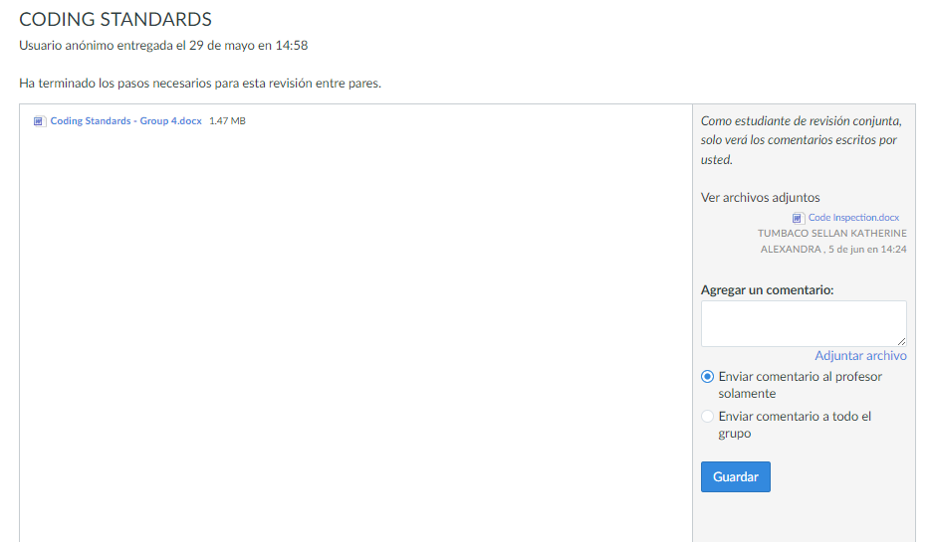

***Activity – PMD***

|  |  |  |  |
| --- | --- | --- | --- |
| **Category** | **Criteria** | **Score – Y/N** | **Comments** |
| **Code Formatting** | Is the code consistently  formatted (indentation, spacing)? | Yes | Is consistently |
| **Are line lengths reasonable and**  **within guidelines?** |  | Yes |  |
| **Are there unnecessary blank**  **lines or spaces?** |  | 5 | No use unnecessary blank lines |
| **Naming Conventions** | Are variable and function names descriptive and  meaningful? | No | Naming conventions are not used correctly |
| **Are naming conventions consistent (camelCase,**  **PascalCase, etc.)?** |  | Yes | Use camelCase |
| **Comments and Documentation** | Are comments used where  necessary and helpful? | No | Does not use comments |
| **Is the code sufficiently documented to understand**  **functionality?** |  | Yes |  |
| **Are comments clear and concise?** |  | No | Does not use comments |
| **Code Structure** | Is the code modular and divided into logical  functions/methods? | Yes |  |
| **Are there any long methods/functions that should**  **be broken down?** |  | No |  |
| **Is there any duplicated code that**  **should be refactored?** |  | No |  |
| **Logic and Functionality** | Does the code function as  intended? | Yes |  |
| **Are all the requirements**  **fulfilled?** |  | Yes |  |
| **Are there any obvious logic**  **errors?** |  | No |  |
| **Are loop cases handled properly?** |  | Yes |  |
| **Error Handling** | Are errors and exceptions properly caught and  handled? | No | Exceptions can be used in the EmailApp |
| **Is there any potential for**  **unhandled exceptions?** |  | Yes |  |
| **Performance and Efficiency** | Are there any obvious  performance bottlenecks? | Yes |  |
| **Is the code optimized for**  **performance where necessary?** |  | Yes |  |
| **Security** | Are there any security  vulnerabilities in the code? | Yes |  |
| **Is input validation properly**  **implemented?** |  | Yes |  |

* Suggestions for improvements variable

* handling exceptions in email application

***PART 2 – Install PMD***

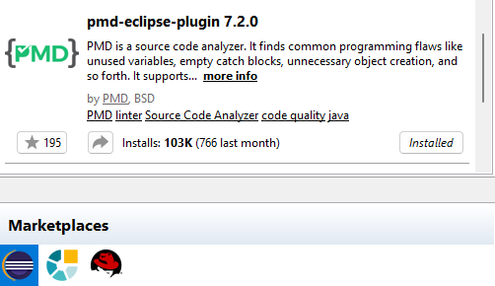

***PART 3 – Configure the project***

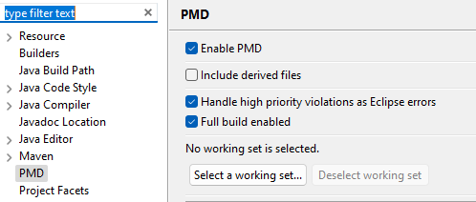

***PART 4 – Using PMD***

***PART 5 – Creating PMD rulesets***

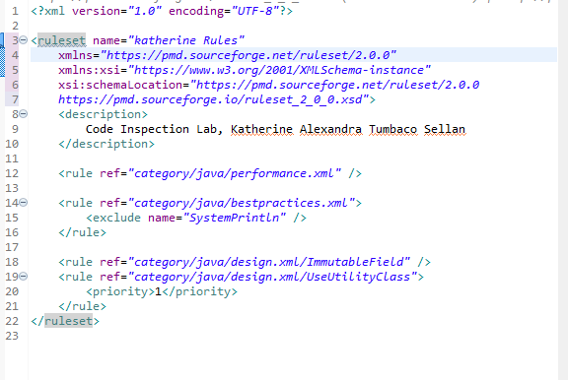

Delete group rules and import 

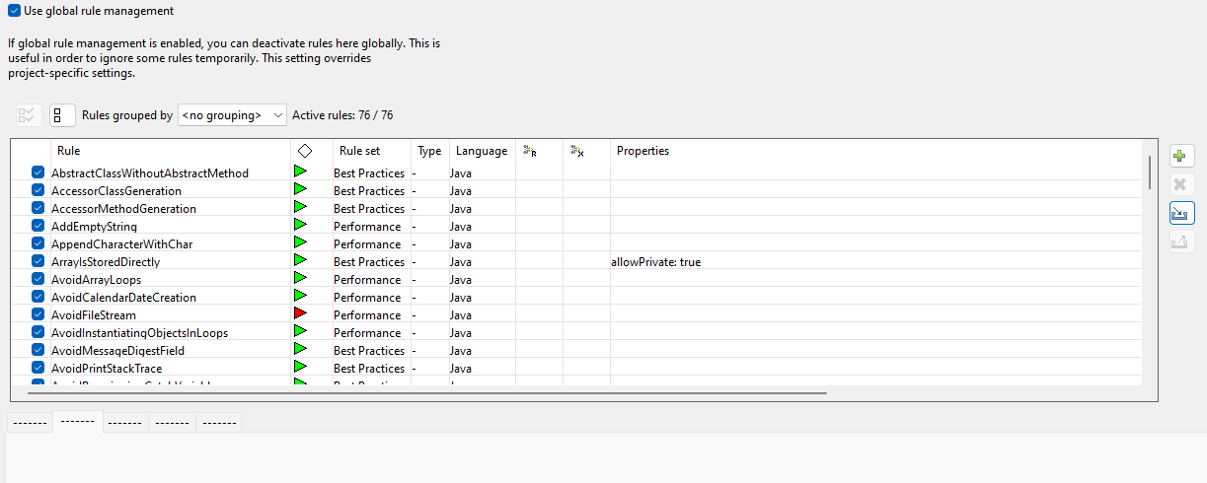

Clear Violations

***Part 6: Generating a PMD report*** 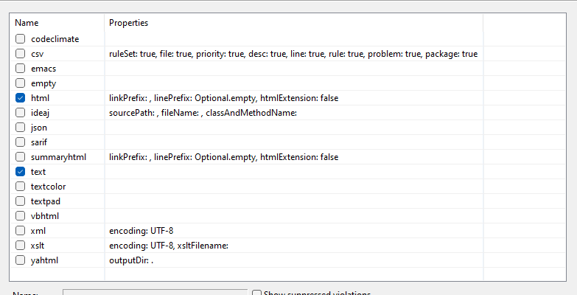

***Part 7: Suppressing PMD Rules***

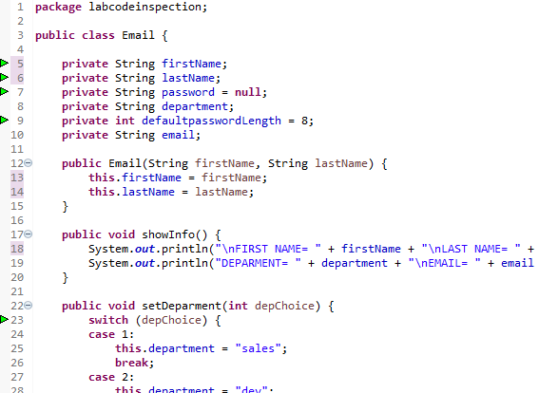

Check the violation in EmailApp and solution.

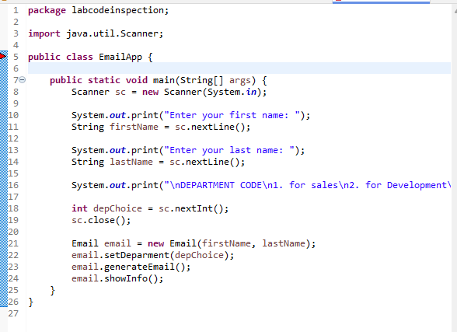

***Part 8: Detecting Cut-and-Paste with CPD***

***Part 9: PMD and Maven***

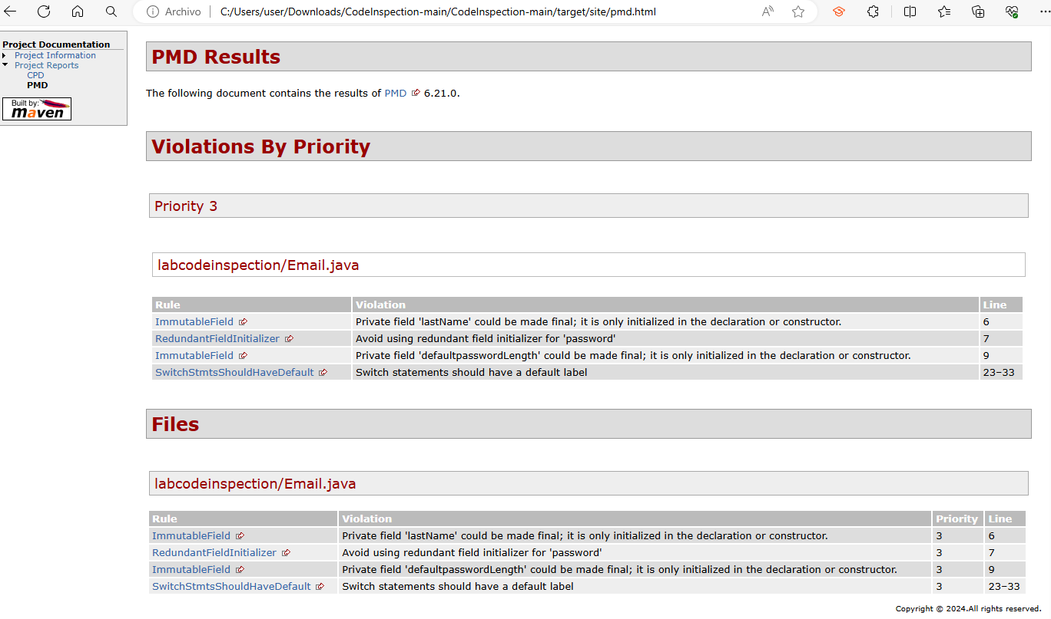

***Development***

I apply the rules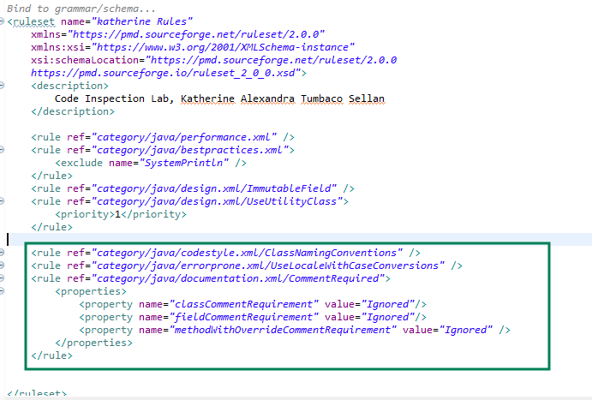

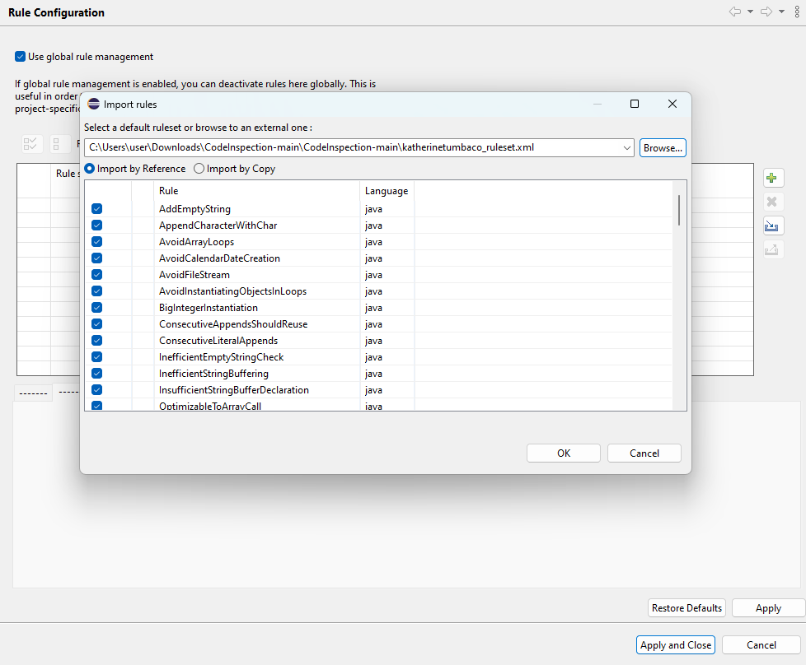

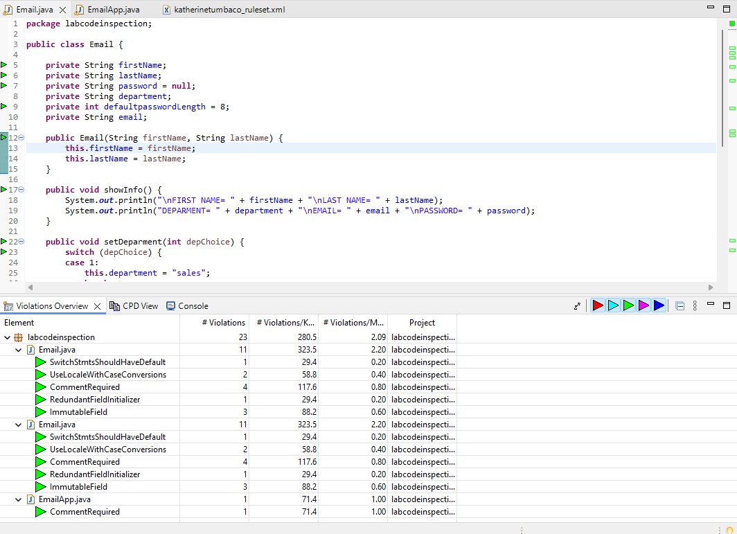

I do Run –> Maven Build

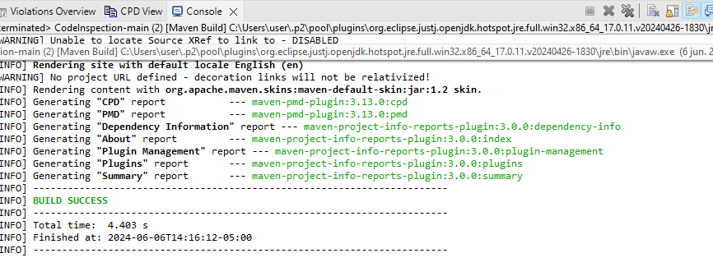

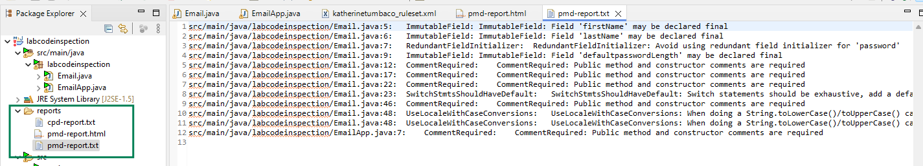

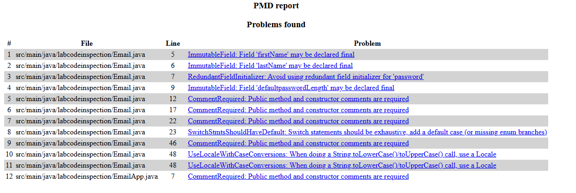

We proceed to look at the details of the violations and correct them.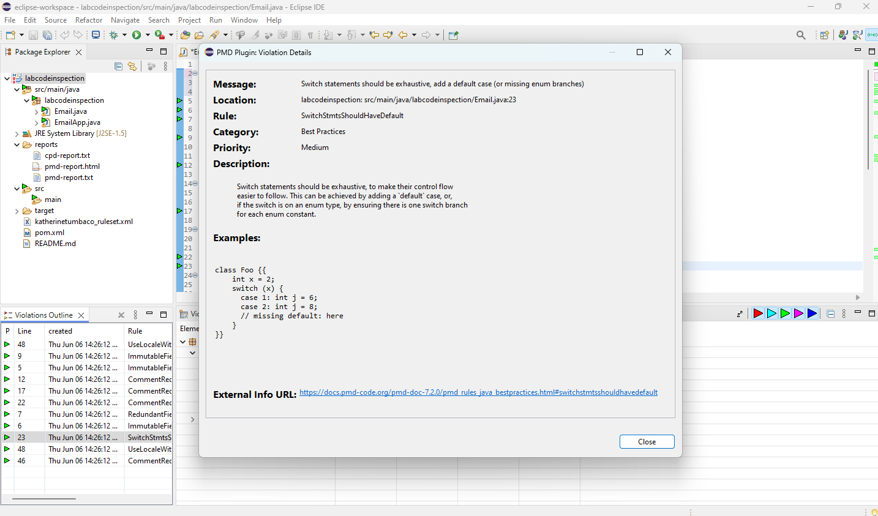

Code corrected

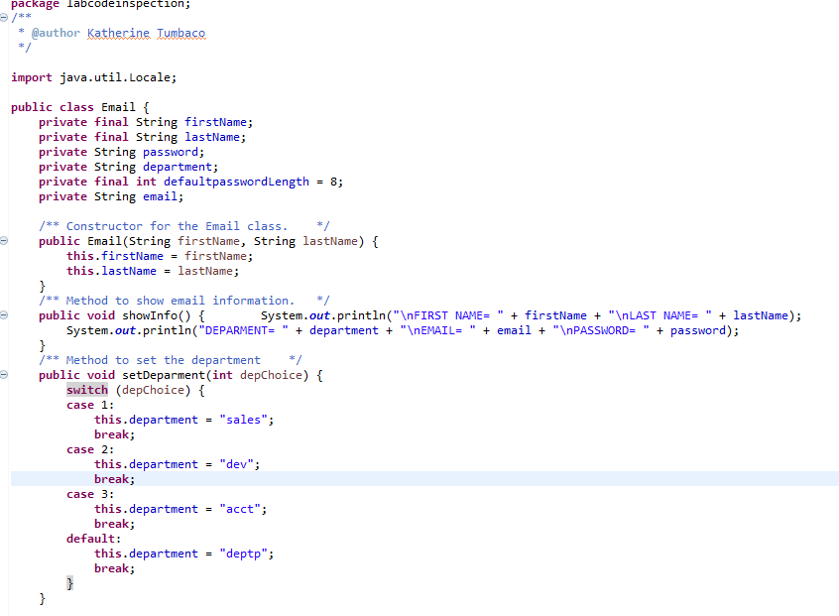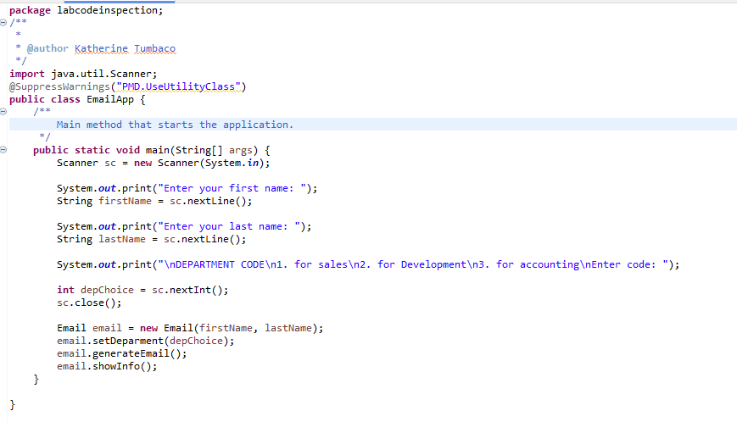

I do Run As-> Maven Build

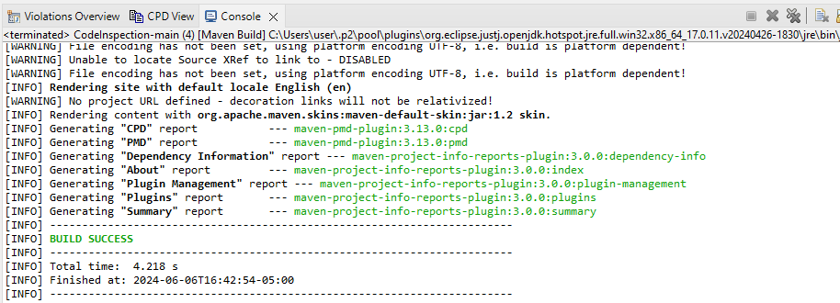

Report is generated and no problems are found.

***Repository:***

<https://github.com/katumbac/CodeInspection.git>

***Notes:***

Rule *BeenMembersShouldSerialize* was not applied because that rule was renamed *NonSerializableClass* and in Eclipse the rule could not be found under that name.

